OPERATION & MAINTENANCE OF GENERATORS

Generators are to be overhauled in accordance with the maintenance schedule in company’s PMS, the instruction book of the engine maker, and whenever the Chief engineer considers it necessary.

When an overhauling is carried out, the wear down for liners, piston ring grooves, and piston rings, etc., are to be measured and recorded using the form of Generator Engine Overhaul Report (E43).

The 2nd engineer is responsible for implementing the maintenance work for the generators and their control equipment.

The Diesel Generator

Every day at a fixed time, the duty engineer shall measure the temperature, the pressure, and the oil quantity etc. of the machine in operation. He also shall confirm the normal operable condition and make an entry of the necessary data in the engine logbook.

After completion of overhaul or exchange of the main parts, the duty engineer officer shall execute the test operation without fail and confirm good normal conditions. He shall, at the same time, take the indicator card and confirm the burning condition of each cylinder.

Long term low load operation is to be avoided as per maker’s instructions

When the maintenance of the S/B machine is required, it shall in principal, be completed 2 days before entering a port and all generator engines shall be kept ready for working on the previous day before entering a port.

The purifying of system oil shall be done every 750 PMS working hours except in the case where the ship has a circulated purifying system, and the cleaning of the sump tanks shall be made every 1500 hours, at which time the crank cases shall also be checked.

A sample of L.O. shall be taken and sent to the manufacturer for their analysis once every six months and it is requested to be always in good working condition.

The 2nd engineer officer shall pay special attention to the condition of the T/C and try to calculate the proper time for exchanging its shaft bearings and overhaul for cleaning.

For ship’s equipped with RH type of turbochargers’ (RH 133/143/163/183),: RH Type T/C Inspection Form is to be filled up during the routine overhauls at 2400 hrs., 4800 hrs. and in case of any breakdowns. This form has also to be filled up if it is decided to overhaul the Turbocharger during the “Rotation Check” done every 500 hrs. The sample photographs included at the end of this chapter are to be taken before and after cleaning. These are the minimum which should be taken and are important to assess the extent of fouling, condition of the casing, bearings etc. Please refer to the sample photographs for guidance.

Smoke condition is to be checked

Tri- Fuel Aux Engines: Tri-fuel engines should be changed from Diesel to Gas mode above 15% load preferably. In the event of gas fuel failure, the engine will ‘Gas Trip’ to diesel operation so supply of Diesel (MDO/MGO) to be maintained at normal levels.

  - Safety devices to be checked as per PMS.
  - Nitrogen purging of the DW pipes to be done after Gas operation.
  - Each A/E GVU to be checked before Gas operation.
  - Waste gate operation to be checked during Gas mode running via the T/C rpm and Scavenge Air pressure.

  - Fuel Changeover for Tri-Fuel Engines:
  - The AE fuel changeover is always done through MGO i.e.:

  - GAS-(MGO-GAS) and GAS-MGO-HFO-MGO-GAS

It is crucial that the changeover between fuels should avoid rapid change in fuel oil temperature. Max rate: 4°C/minute.

- GAS-MGO: Transfer is instantaneous and can be done at any load without restrictions.
- MGO-GAS: Transfer can be done on loads approx. 10~80% Load. The engine should operate on MGO for a min period of 60 minutes before transfer to gas.
- HFO-MGO: Transfer can be done at any load, subject to slow temperature changes.

The Turbo Generator

Every day at a fixed time, the duty engineer officer shall measure the temperature, pressure and oil quantity etc. of the machine in operation. He shall confirm the normal operable condition and make entries of the necessary data in the engine logbook.

The existence or non-existence of the moisture mixing in the L.O. drain tank shall be regularly checked and the 2nd engineer officer shall make an effort to keep the good working condition by taking and sending a L.O. sample to the manufacturer once a year for their analysis.

The Emergency Generator

A test operation shall be conducted once a week to confirm the operable condition of each part and the proper quantity of F.O. and L.O. shall be confirmed. This data shall be recorded in the record book and/or Engine Logbook.

In case of the starting system being battery powered, a voltage check of the battery shall be made properly (at least once every 2 weeks) and battery shall be charged properly.

In case of an air starting system, the air pressure shall be confirmed, and the test operation of the emergency compressor shall be executed.

In case of a hydraulic starting system, the hydraulic pressure shall be confirmed and the operation of the hydraulic accumulator shall be executed.

BOILER OPERATION & MAINTENANCE

Boilers vary greatly between dry cargo ships and tankers and depending upon burner types. It is therefore important for all engineers to understand and follow maker’s instructions for boiler and burner operation.

Aux. Boiler water is to be tested and checked every three days and the results to be reported to company once a month, using the form of Boiler water analysis report.

Testing of boiler water by a shore technician is to be carried out once every 6 months.

The 3rd engineer officer for vessels other than Tankers, or 2nd Engineer Officer in case of a Tanker, is responsible for implementing the maintenance work for the Aux. boiler and its accessories.

Soot blowing of the generating and super heater tubes of the economizer shall be carried out twice a day. Boiler tubes should be soot blown prior to arrival and after departure from a Port and not in the port. This shall be recorded in the engine logbook. The chemical for soot release shall be fed within 1 hour before the soot blowing, if supplied. At Sea, the officer on Bridge watch should be consulted prior commencing, and course altered if necessary.

The differential pressure between the gas inlet and outlet of the economizer shall be checked every day, if fitted.

The gas inlet temperature of the economizer shall be checked every day.

The gas side of the economizer tubes shall be cleaned regularly with fresh water.

The boiler water-circulating pump shall be run continuously even after the main engine is stopped, to ensure that soot fires and low temperature corrosion are prevented from taking place.

Smoke condition to be checked

STEERING GEAR

The general inspection of the steering gears is carried out as described below and the routine maintenance as per the maker’s instruction and the company’s PMS.

Before entering or leaving a port, the steering gear, including its control units, such as auto-pilot, the rudder angle indicator, lubricant condition of rudder carrier, lube oil level in head tank and attached storage tank etc., are to be checked, tested.

The 1st engineer officer is responsible for implementing the maintenance work for the steering gears.

The following items are to be confirmed once a day during a voyage.

The oil quantity and temperature of L.O. Head Tank.

The existence or non-existence of a L.O. leak from the gears and piping systems.

The L.O. condition in the rudder carrier (Grease quantity, if grease is used).

The discharge pressure and the ampere of the hydraulic pressure pump (including those of the auxiliary pump, if it is installed).

The discharge pressure of the autopilot hydraulic pressure pump (when so equipped).

The rudder angle indicator link mechanism.

The ground seal condition of the rudder stock.

GCU (GAS COMBUSTION UNIT)

The GCU burns unutilized gas. Therefore, it is waste of gas. The use of GCU to be minimized to ensure max utilization of Natural BOG on LNG carriers.

HIGH VOLTAGE SYSTEMS

- High voltage systems refer to systems or component handling above 1000VAC. Following to be complied when working on High voltage systems:

Risk assessment to be done.

Permit to work has been issued.

Lock out /tag out procedures have been applied.

High voltage switching plan is made

Restrict access to high voltage work site by the use of barriers.

Follow manufacturer’s instructions.

Earth at all points of disconnection through earthing switches.

Certified high voltage PPE must be worn.

Follow the isolation procedures and switching plan.

Do not adjust or remove protective devices.

Remove all isolations only upon completion of all work.

Prove the function of all protective device prior to reinstating the system.

Close permit to work upon completion.

- Switching plan:

A switching plan is the correct method for high voltage isolation planning. The switching plan incorporates the intended method of switching, isolating and earthing, required to isolate or reinstate high voltage equipment. Include the following in the switching plan:

Review of all the circuit diagrams and reference material

Confirmation that all equipment on circuit diagram is as fitted.

Correct identification of work site

Initial state of the system ie; live or dead.

Isolation, lock out and earthing procedure of all equipment relevant to the maintenance.

Restriction of access around the work site using barriers.

The sequence for reinstating the system including the order of removing isolations.

Nominated stand by man for work locations.

NITROGEN PLANT

- Nitrogen air compressors should be regularly overhauled following maker’s instructions and PMS, and the condition of produced N₂ always kept dry and oil free by maintaining the oil separators and driers/filters. Oil contamination of the generator membrane bundle will considerably reduce the life of this high cost item. Alarms and trips must be tested regularly.

- Daily inspection should be done as per Maker’s instructions as also consumption of N₂ gas for leakages. The Oxygen analyzer and dew point meter must be calibrated at the frequency indicated in the PMS system. Office is to be notified immediately if signs of deterioration of N2 capacity and quality is observed.

- SAMPLE PHOTOGRAPHS FOR RH TYPE OF TURBOCHARGERS

The below sample photo are for guidance. Similar photographs are to be taken at the time of overhaul and sent to office.

Compressor wheel before disassembly | Turbine wheel before disassembly
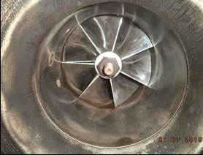 | 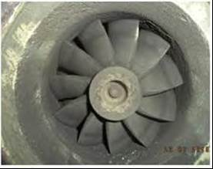
Gas Inlet Casing | Gas Outlet Casing
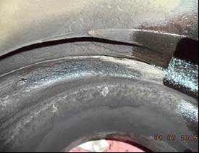 | 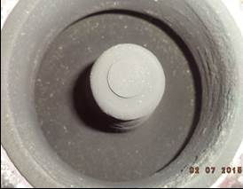
Seal Ring Recess | Compressor wheel and housing
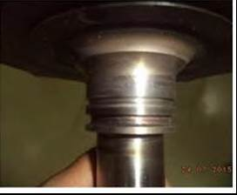 | 

Turbine Shaft | Thrust and sleeve bearing
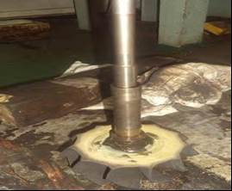 | 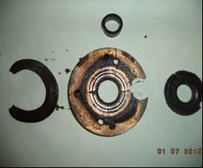

-x-

